**Network Fundamentals Week 10 Log Book**

**Summary**

In star topology it is best to reduce the amount of the effect of a device going down by spreading the network devices evenly across various switches or hubs.

The subnet mask splits the IP address and tells the network which part is the network ID and which part is the host ID. E.g. a subnet mask of 255.255.255.0 with an IP address of 10.10.1.1 tells us that the first 3 bits are part of the network ID and the last bit is the host ID.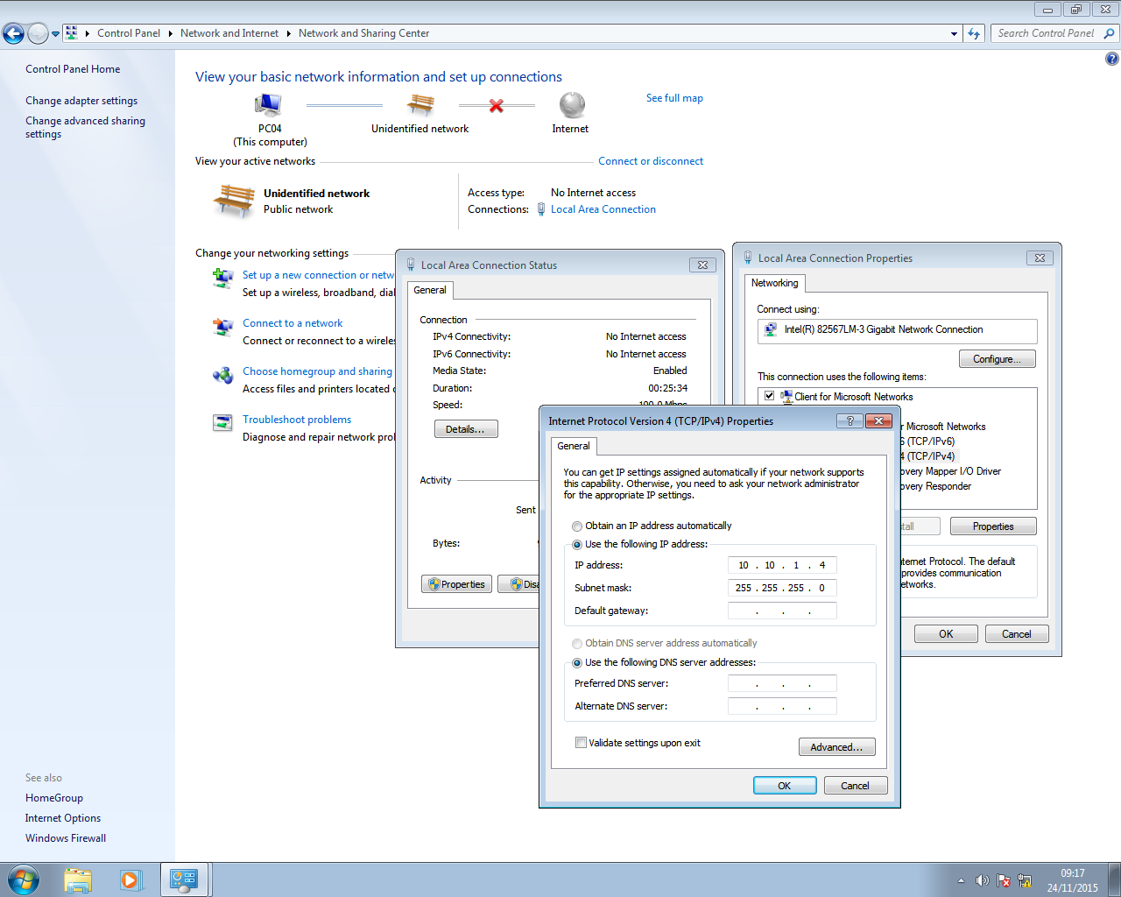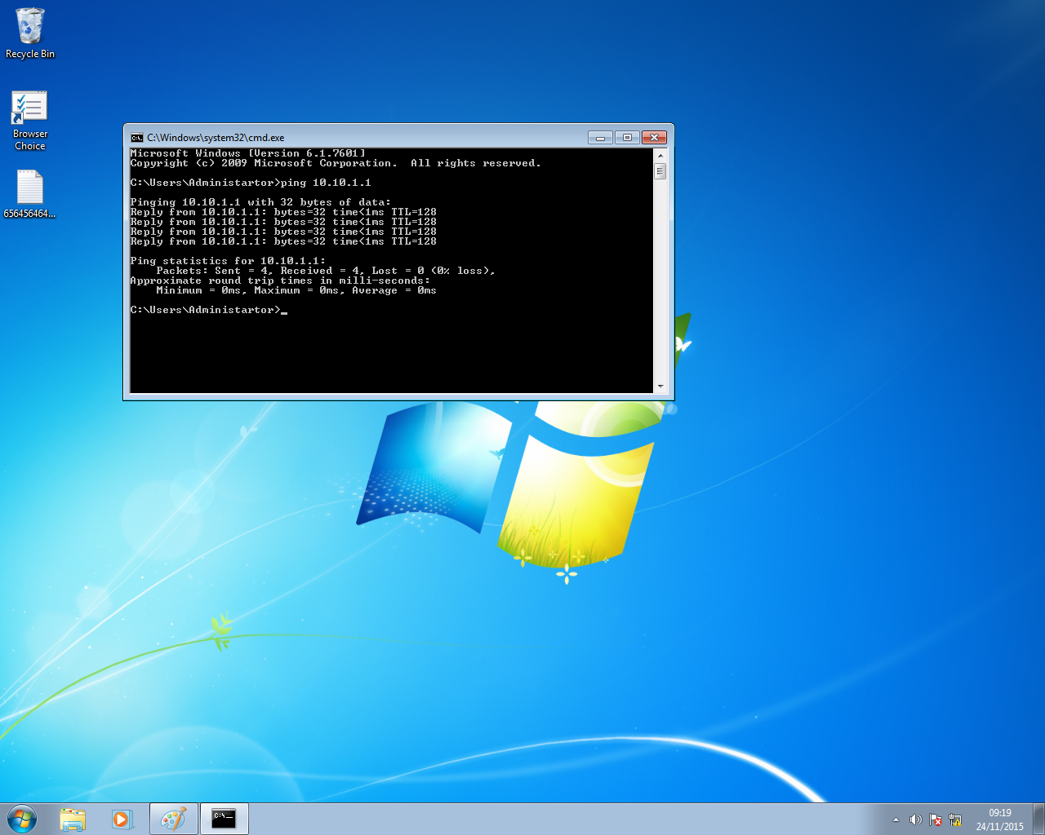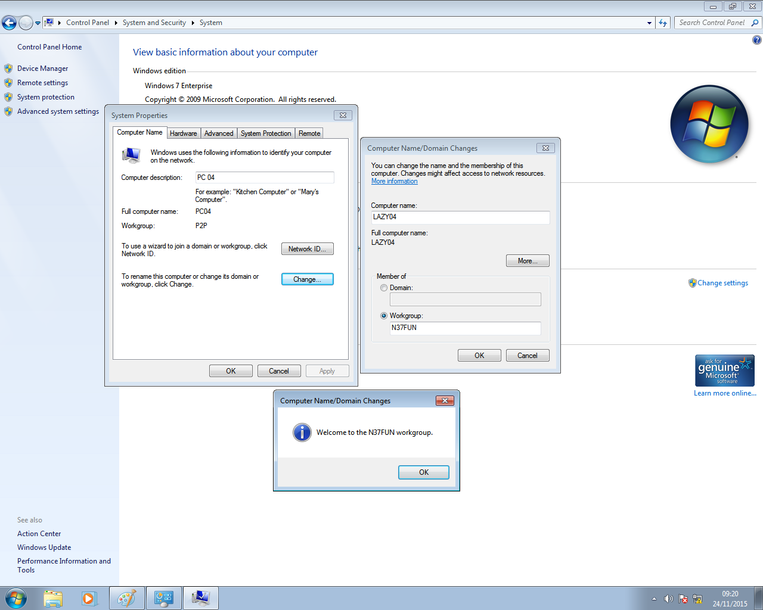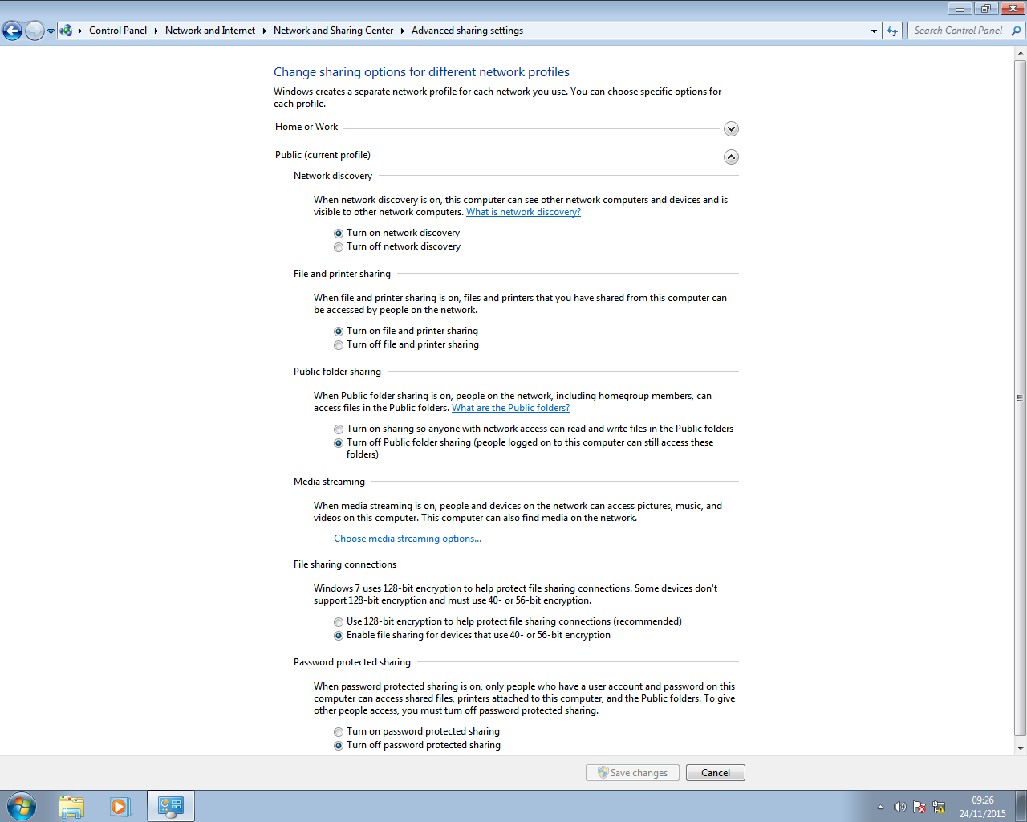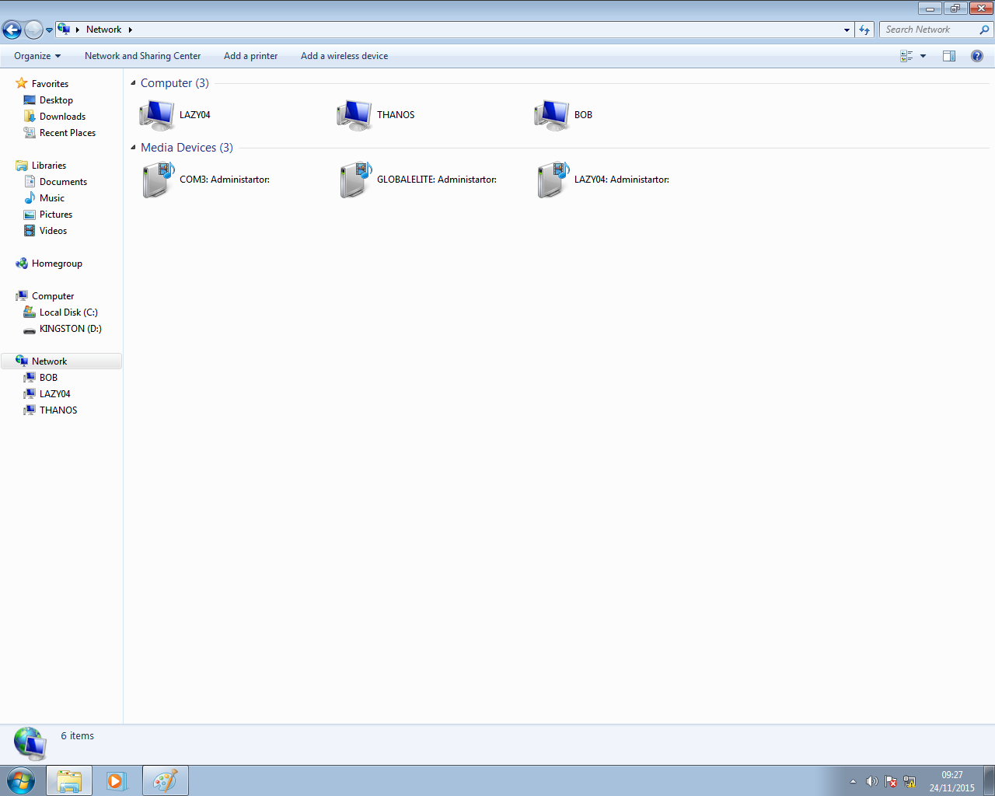

**Implementation**

We set the network up in pretty much the same way as the Ethernet network that consisted of only two PC’s except that this time, instead of connecting to the other computers directly, we connected to a switch as a medium which allowed us to connect to more computers than just the other one.

**Results**

It took a while but we managed to connect all PC’s in the lab together, some people had issues with firewalls blocking access to and from their computers.

**Conclusion**

This network is rather useful for connecting medium to large networks and isn’t too difficult to setup. Windows configuration is practically the same as setting up a basic Ethernet network.